DIGITAL SIGNAL PROCESSING LABORATORY
EXPERIMENT 9
Uniform Quantization and Finite Word-Length Effects in Digital Signal Processing Using MATLAB
Date of Experiment | 12 October 2026
Course | B.E. Electronics and Communication Engineering (ECE)

1. OBJECTIVES
- To perform uniform quantization of a sinusoidal signal using rounding and truncation.
- To calculate quantization error and signal-to-quantization-noise ratio (SQNR).
- To compare quantization performance for different word lengths.
- To observe the effect of finite word length on quantization error and SQNR using MATLAB.

2. MATLAB PROGRAM
clc;
clear;
close all;

%% PARAMETERS
A = 1;
f = 50;
Fs = 1000;
N = 1000;

n = 0:N-1;
x = A*sin(2*pi*f*n/Fs);

B = 8;
bits = [4 8 12 16];

%% 1. 8-BIT QUANTIZATION
D = 2*A/2^B;

xr = D*round(x/D); % Rounding
xt = D*fix(x/D); % Truncation

er = x - xr; % Rounding error
et = x - xt; % Truncation error

SQr = 10*log10(mean(x.^2)/mean(er.^2));
SQt = 10*log10(mean(x.^2)/mean(et.^2));

%% 2. INPUT / OUTPUT QUANTIZATION
xq = xr;
y = x;
yq = D*round(y/D);
eo = y - yq;

SQout = 10*log10(mean(y.^2)/mean(eo.^2));

%% 3. WORD-LENGTH COMPARISON
step = zeros(size(bits));
sqnrR = zeros(size(bits));
sqnrT = zeros(size(bits));
maxER = zeros(size(bits));
maxET = zeros(size(bits));

for k = 1:length(bits)
b = bits(k);
d = 2*A/2^b;

qr = d*round(x/d);
qt = d*fix(x/d);

er1 = x - qr;
et1 = x - qt;

step(k) = d;
sqnrR(k) = 10*log10(mean(x.^2)/mean(er1.^2));
sqnrT(k) = 10*log10(mean(x.^2)/mean(et1.^2));

maxER(k) = max(abs(er1));
maxET(k) = max(abs(et1));
end

%% 4. DISPLAY RESULTS
fprintf('\\n========== QUANTIZATION RESULTS ==========\\n');
fprintf('Amplitude = %.1f | Frequency = %d Hz | Fs = %d Hz\\n',A,f,Fs);
fprintf('Samples = %d | Main word length = %d bits\\n',N,B);
fprintf('8-bit Step Size = %.7f\\n',D);
fprintf('Rounding SQNR = %.4f dB\\n',SQr);
fprintf('Truncation SQNR = %.4f dB\\n',SQt);
fprintf('Output SQNR = %.4f dB\\n',SQout);
fprintf('Max Rounding Error = %.6f\\n',max(abs(er)));
fprintf('Max Truncation Error = %.6f\\n',max(abs(et)));

%% 5. FIRST 10 SAMPLES TABLE
T1 = table(n(1:10)',x(1:10)',xr(1:10)',er(1:10)', ...
xt(1:10)',et(1:10)', ...
'VariableNames',{'n','Original','Rounded','RoundError', ...
'Truncated','TruncError'});

disp('FIRST 10 SAMPLES');
disp(T1);

%% 6. WORD-LENGTH TABLE
T2 = table(bits',step',sqnrR',sqnrT',maxER',maxET', ...
'VariableNames',{'Bits','StepSize','SQNR_Round_dB', ...
'SQNR_Trunc_dB','MaxError_Round','MaxError_Trunc'});

disp('WORD-LENGTH COMPARISON');
disp(T2);

%% 7. OUTPUT PARAMETER TABLE
Parameter = {
'Quantized signal'
'Quantization error'
'SQNR'
'Word-length comparison'
};

Observation = {
sprintf('8-bit rounding, Delta = %.7f',D)
sprintf('Max rounding error = %.6f',max(abs(er)))
sprintf('Rounding = %.4f dB; Truncation = %.4f dB',SQr,SQt)
'SQNR increases as word length increases'
};

Unit = {
'Amplitude'
'Amplitude'
'dB'
'Bits / dB'
};

Output_Table = table(Parameter,Observation,Unit);

disp('OUTPUT PARAMETER TABLE');
disp(Output_Table);

%% 8. ORIGINAL AND QUANTIZED SIGNAL
figure;
plot(n(1:100),x(1:100),'b','LineWidth',1.2);
hold on;
stairs(n(1:100),xr(1:100),'r--','LineWidth',1.2);
grid on;
xlabel('Sample n');
ylabel('Amplitude');
title('Original and 8-bit Quantized Signal');
legend('Original','Quantized');

%% 9. ROUNDING AND TRUNCATION ERROR
figure;
plot(n,er,'b','LineWidth',1.1);
hold on;
plot(n,et,'r--','LineWidth',1.1);
grid on;
xlabel('Sample n');
ylabel('Error');
title('Rounding and Truncation Quantization Error');
legend('Rounding','Truncation');

%% 10. SQNR VS WORD LENGTH
figure;
plot(bits,sqnrR,'o-','LineWidth',1.5);
hold on;
plot(bits,sqnrT,'s--','LineWidth',1.5);
grid on;
xlabel('Word Length (bits)');
ylabel('SQNR (dB)');
title('SQNR vs Word Length');
legend('Rounding','Truncation');

%% 11. QUANTIZATION ERROR VS WORD LENGTH
figure;
semilogy(bits,maxER,'o-','LineWidth',1.5);
hold on;
semilogy(bits,maxET,'s--','LineWidth',1.5);
grid on;
xlabel('Word Length (bits)');
ylabel('Maximum Quantization Error');
title('Quantization Error vs Word Length');
legend('Rounding','Truncation');

%% 12. FINAL RESULT
fprintf('\\n========== FINAL RESULT ==========\\n');
fprintf('Uniform quantization using rounding and truncation was performed.\\n');
fprintf('Quantization error and SQNR were calculated.\\n');
fprintf('Increasing word length reduces quantization error and improves SQNR.\\n');
fprintf('Finite word-length effects are therefore verified.\\n');

3. OUTPUT SCREENSHOTS
The screenshots below show the MATLAB plots and numerical output for the quantization experiment.
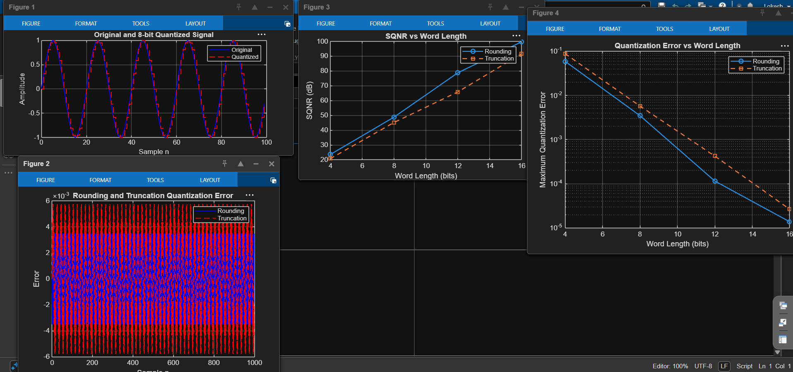
Figure 1. Quantized signal, quantization error, SQNR, and error versus word length.
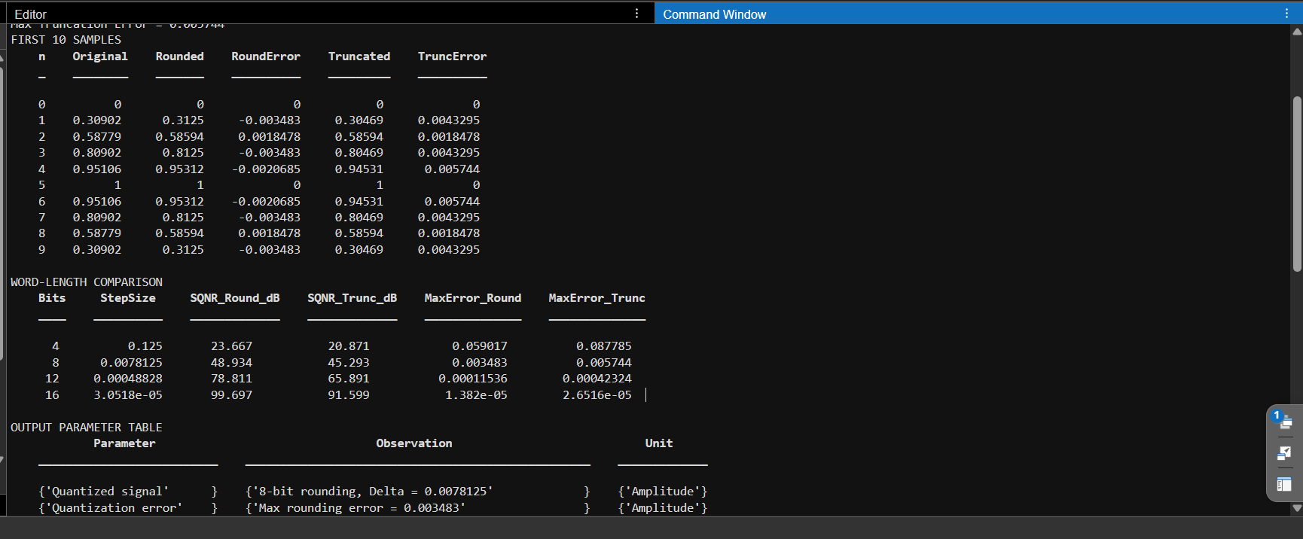
Figure 2. MATLAB command-window output, sample values, word-length comparison, and output parameter table.

4. SIMULATION PARAMETERS
Parameter | Value
Signal amplitude | 1
Signal frequency | 50 Hz
Sampling frequency | 1000 Hz
Number of samples | 1000
Main quantizer word length | 8 bits
Compared word lengths | 4, 8, 12, 16 bits

5. APPLICATIONS
- Analog-to-digital conversion (ADC) in digital systems.
- Audio and speech signal processing.
- Digital communication systems and sensor data acquisition.
- Evaluating the effect of finite word length in digital signal processing hardware.

6. RESULT
Uniform quantization was performed using rounding and truncation. The quantization errors and SQNR values were calculated, and different word lengths were compared. The results demonstrate that increasing word length generally reduces quantization error and improves SQNR.

DONE BY
Lokesh A (192512293)
B.E. Electronics and Communication Engineering (ECE)

